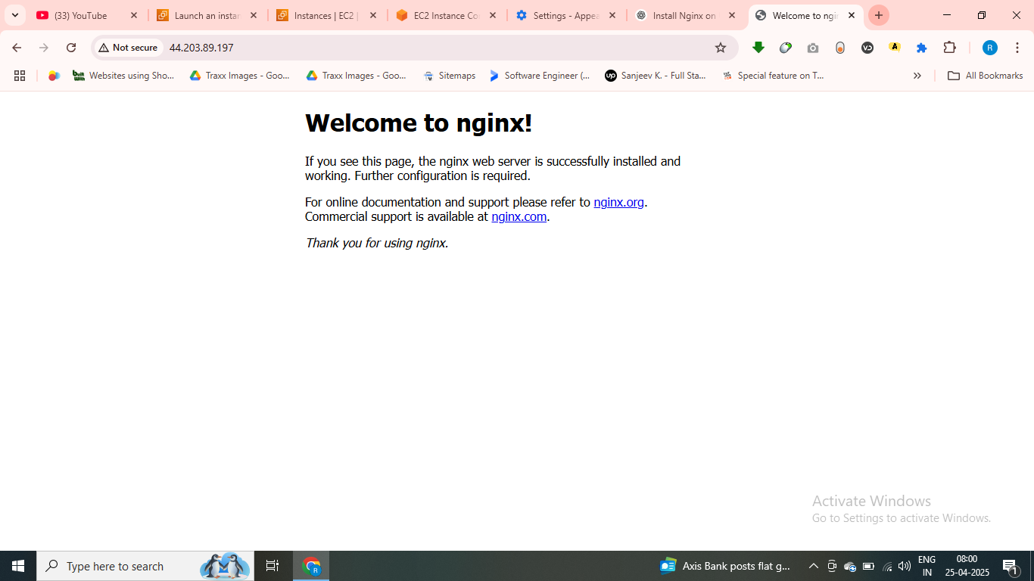

Apacha4e [age

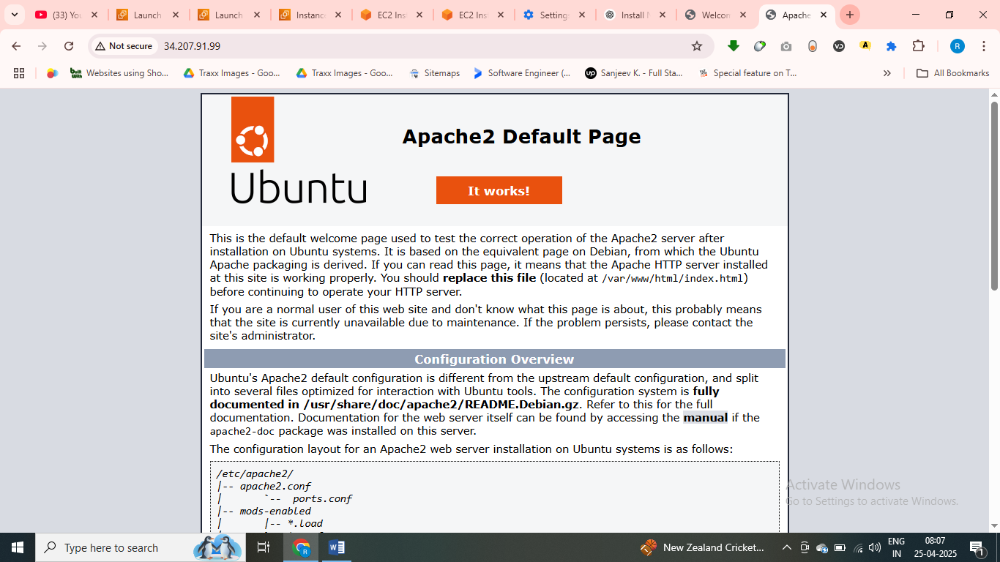\\\\

**You said:**

To run a command as administrator (user "root"), use "sudo <command>". See "man sudo_root" for details. ubuntu@ip-172-31-91-70:~$ - install nginx on this instnace

**ChatGPT said:**

To install **Nginx** on your Ubuntu instance, you need to run a few commands with sudo. Here's a quick step-by-step:

**1. Update your package list**

bash

CopyEdit

sudo apt update

**2. Install Nginx**

bash

CopyEdit

sudo apt install nginx -y

**3. Start Nginx and enable it on boot**

bash

CopyEdit

sudo systemctl start nginx

sudo systemctl enable nginx

**4. Check Nginx status**

bash

CopyEdit

sudo systemctl status nginx

You should see that it’s “active (running)”.

**Optional: Allow Nginx through the firewall**

If you’re using ufw (Uncomplicated Firewall), allow Nginx:

bash

CopyEdit

sudo ufw allow 'Nginx Full'

sudo ufw enable

Once installed, you can visit your server’s public IP in a browser to see the Nginx welcome page.

Let me know if you're using AWS, Azure, or another provider—some need extra security group changes to allow HTTP (port 80).

4o

**You said:**

install apache now on my instnace

**ChatGPT said:**

You got it! To install **Apache** on your Ubuntu instance, just follow these steps:

**🔧 Step-by-step Apache Installation:**

**1. Update packages (again, just in case)**

bash

CopyEdit

sudo apt update

**2. Install Apache2**

bash

CopyEdit

sudo apt install apache2 -y

**3. Start Apache and enable it to run on boot**

bash

CopyEdit

sudo systemctl start apache2

sudo systemctl enable apache2

**4. Check Apache status**

bash

CopyEdit

sudo systemctl status apache2

You should see active (running) in green.

**🌐 Optional: Allow HTTP/HTTPS through firewall**

If you're using ufw:

bash

CopyEdit

sudo ufw allow 'Apache Full'

sudo ufw enable

**✅ Check it in your browser**

Head to your instance's **public IP** in a browser—Apache’s default welcome page should appear.

Want to run both **Apache and Nginx** at the same time? You can, but let me know because you'll need to tweak ports or use Apache as a backend and Nginx as a reverse proxy.

Need help with that setup?

4o

**You said:**

what is nginx and explain forwared proxy and reverse prxy why to use

**ChatGPT said:**

Great question — let’s break it all down clearly and simply:

**🚀 What is Nginx?**

**Nginx (pronounced "engine-x")** is a high-performance web server and **reverse proxy** server.

It can do multiple jobs:

* Serve **web content** (like HTML, CSS, JS, images)
* Act as a **reverse proxy** (pass requests to backend servers)
* Handle **load balancing** (distribute traffic across servers)
* Serve as a **cache** (for speed)
* Act as a **mail proxy** (for SMTP, POP3, IMAP)

Nginx is known for its **speed**, **low memory usage**, and ability to handle **lots of connections** at once.

**🔄 Forward Proxy vs Reverse Proxy**

**➡️ Forward Proxy**

**What it is:** A forward proxy sits **in front of the client (user)**. It hides the client's identity from the server.

**Use cases:**

* Bypassing geo-blocking (like accessing region-locked content)
* Filtering traffic (like parental controls)
* Anonymizing the client (like Tor or VPNs)

**Example:** You (client) → Proxy → Google  
Google never knows it’s *you* who sent the request.

**⬅️ Reverse Proxy**

**What it is:** A reverse proxy sits **in front of the server**. It hides the server's details from the client.

**Use cases:**

* Load balancing traffic to multiple backend servers
* Protecting your app servers from direct exposure
* SSL termination (handle HTTPS)
* Caching and compression to speed things up

**Example:** Client → Nginx → App Server  
Nginx takes requests and sends them to the backend (e.g., Apache, Node.js, etc.)

**🧠 Why Use a Reverse Proxy like Nginx?**

* 🔐 **Security**: Hides backend servers, can block bad traffic
* 🚀 **Performance**: Caches static content, reduces load on app servers
* ⚖️ **Load Balancing**: Distributes requests across multiple servers
* 🔁 **Flexibility**: Can serve different apps on different paths or domains

**💡 Real-World Analogy**

Imagine a restaurant:

* **Forward Proxy**: You (client) send your order to a waiter (proxy), who passes it to the kitchen. The kitchen never knows *you*, just the waiter.
* **Reverse Proxy**: You (client) give your order to the front desk (reverse proxy). They figure out *which* chef (backend server) should handle it. You never interact with the chef directly.

Let me know if you want a demo setup with Nginx as a reverse proxy for Apache or another app!

4o

**You said:**

in simple lang please like intrmediate between server and client

**ChatGPT said:**

Absolutely! Let’s simplify it all — like you're explaining it to a friend:

**💡 What is Nginx?**

**Nginx** is a tool (or software) that helps serve websites to people. It can:

* Show websites (like a basic web server)
* Sit **between** users and your actual website to **help manage traffic**
* Make things **faster and safer**

**🧍‍♂️➡️🔀⬅️🖥️ What is a Proxy?**

Think of a **proxy** like a **middleman** or a **messenger** between the user and the server.

There are **two main types**:

**🔄 Forward Proxy (For the Client/User)**

* Sits **in front of the user**.
* Sends requests to the internet **on behalf of the user**.
* Hides the user’s identity from the websites they visit.

📦 **Example:**  
You want to visit a website, but you're in a country where it's blocked.  
So you use a **forward proxy** to access it. The website thinks the request came from the proxy, not you.

**🔁 Reverse Proxy (For the Server)**

* Sits **in front of the server**.
* Handles incoming traffic **on behalf of the server**.
* Hides and protects the real server.

📦 **Example:**  
You visit a website. Instead of going directly to the real server, your request goes to **Nginx** (reverse proxy).  
Nginx then decides which server should handle the request — maybe it picks the fastest or the least busy one.

**✅ Why Use a Reverse Proxy (like Nginx)?**

* **More secure**: People don’t see your real servers
* **Faster**: Nginx can cache things (save copies) and serve them quickly
* **Smart traffic control**: Send users to different servers if one is full or down

**🧠 In One Line:**

A **proxy** is a middleman.  
A **forward proxy** helps the **user**.  
A **reverse proxy** helps the **server**.

Let me know if you want me to draw a diagram or show a real example using Apache + Nginx.